Figure 1: Adding files 2

Figure 2: Adding codes in index.html 2

Figure 3: Resources.txt file (name added) 3

Figure 4: Basic Github code done 3

Figure 5: Files added 4

Figure 6: Initial commit 4

Figure 7: Checking Git status 5

Figure 8: Modified resources.txt file 5

Figure 9: Commit added 6

Figure 10: Repository created 6

Figure 11: Files added and cloned in repository 7

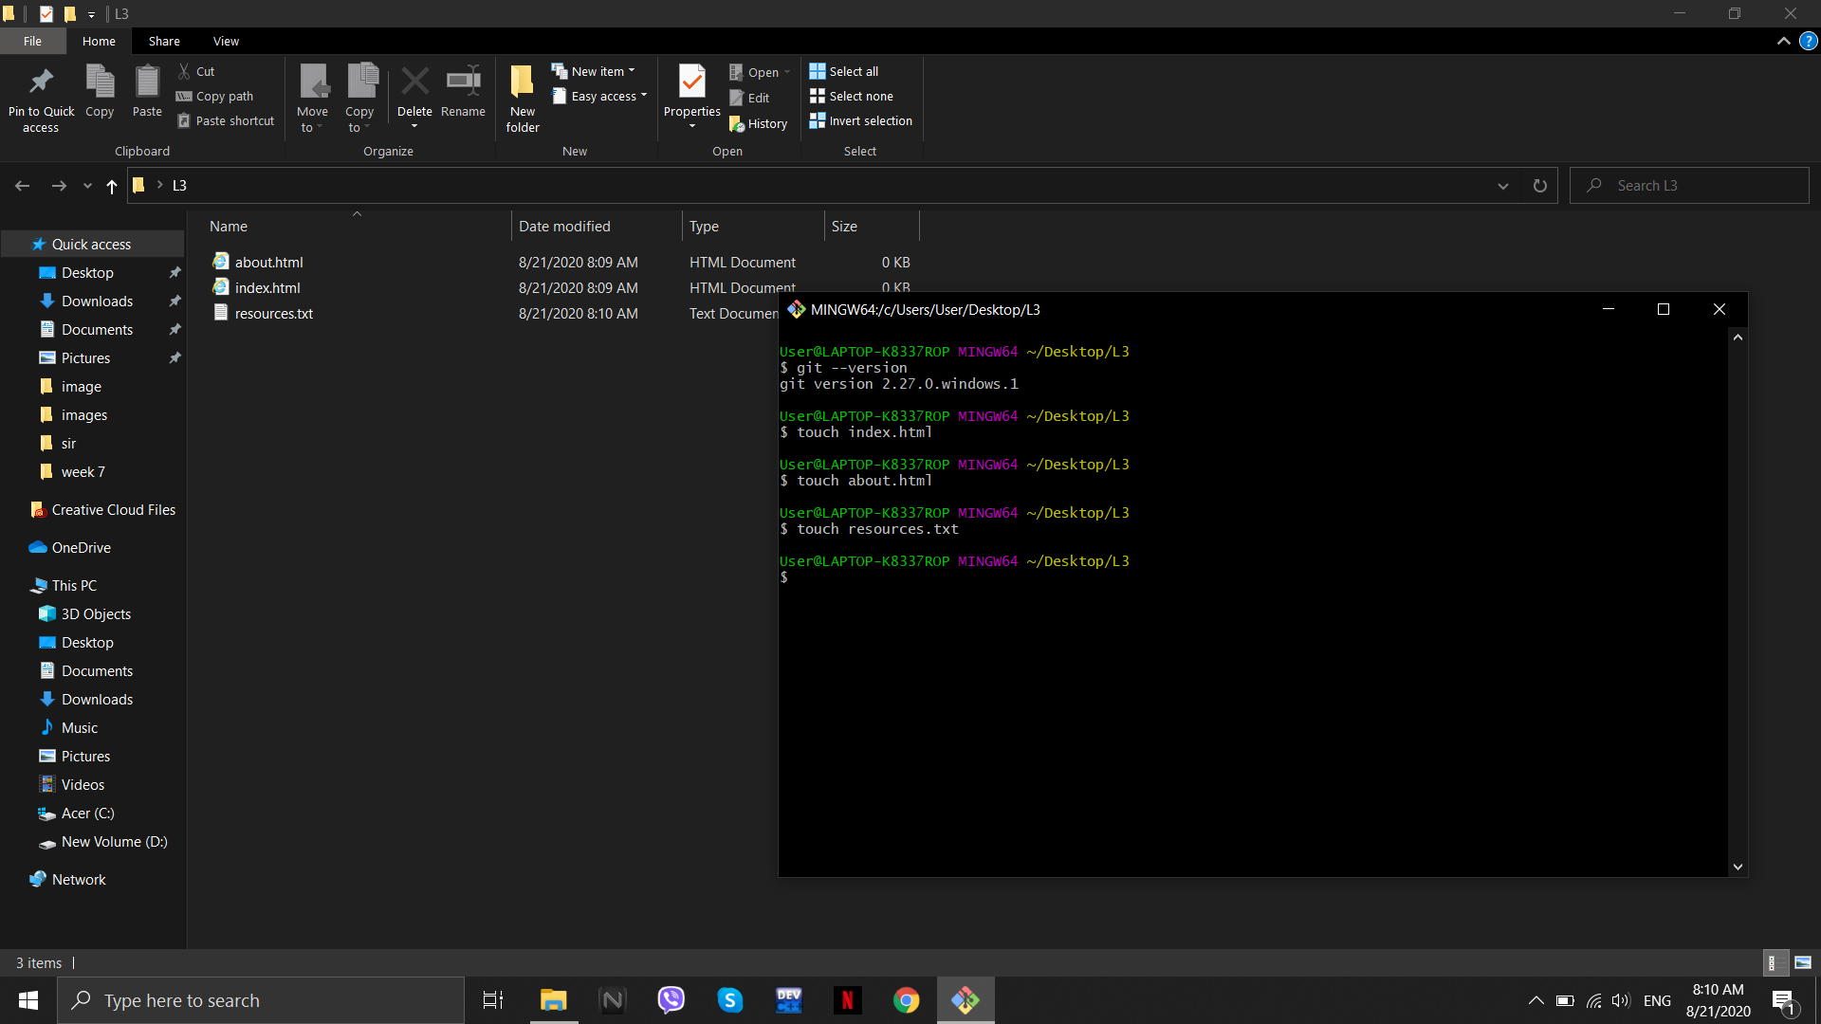

Figure 1: Adding files

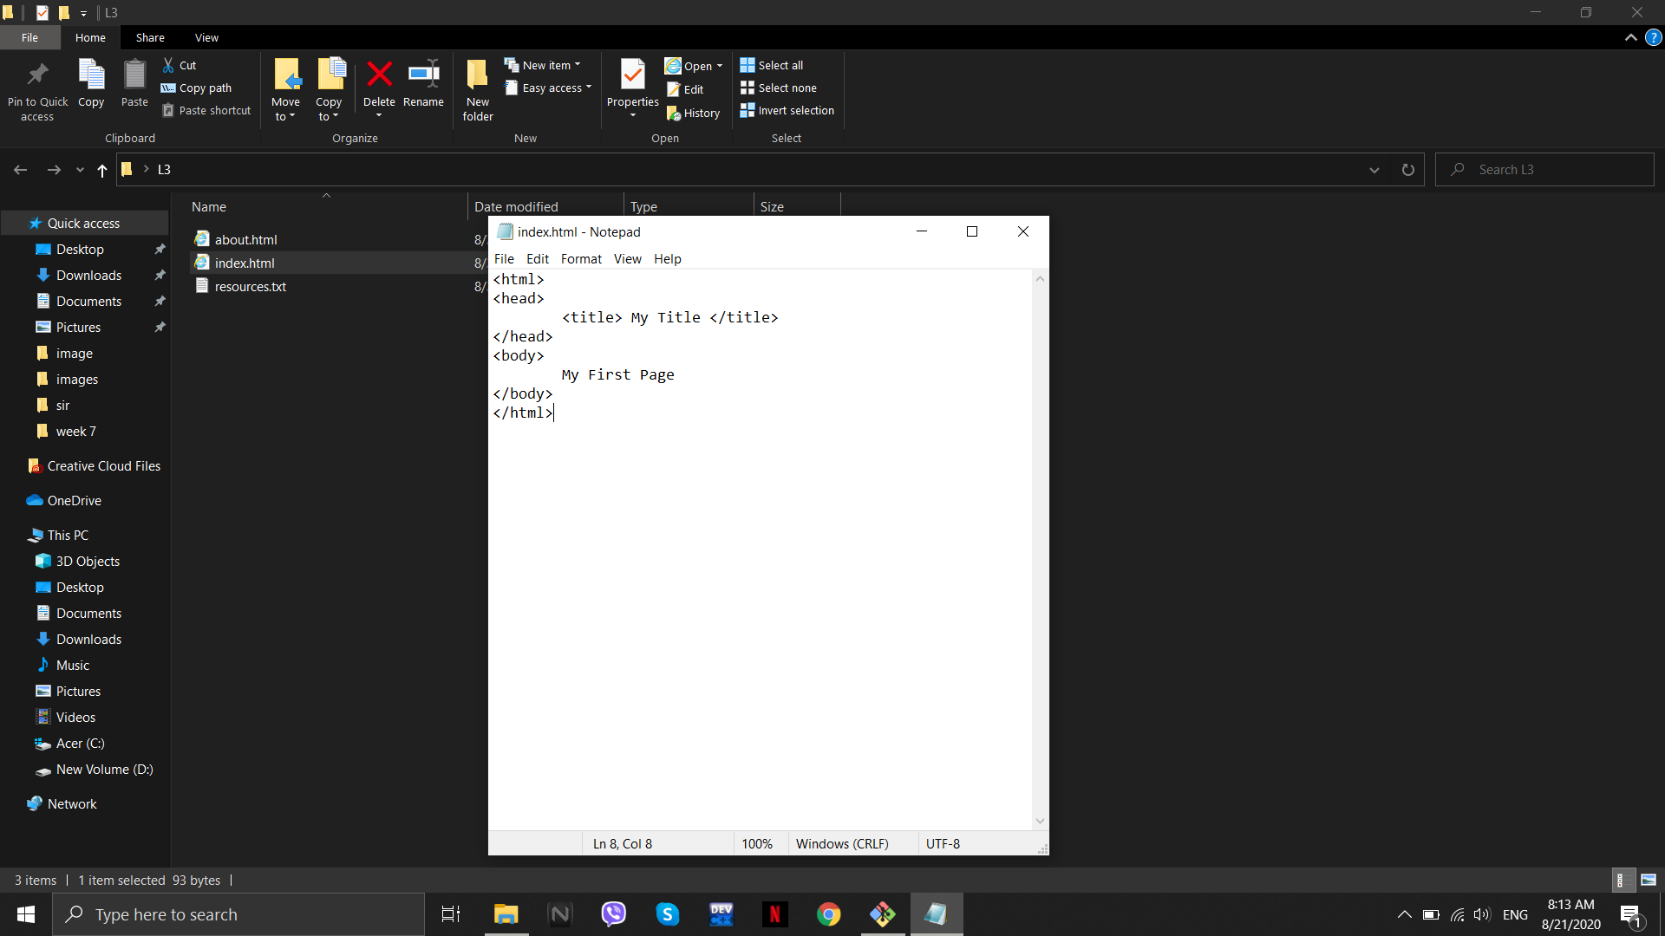

Figure 2: Adding codes in index.html

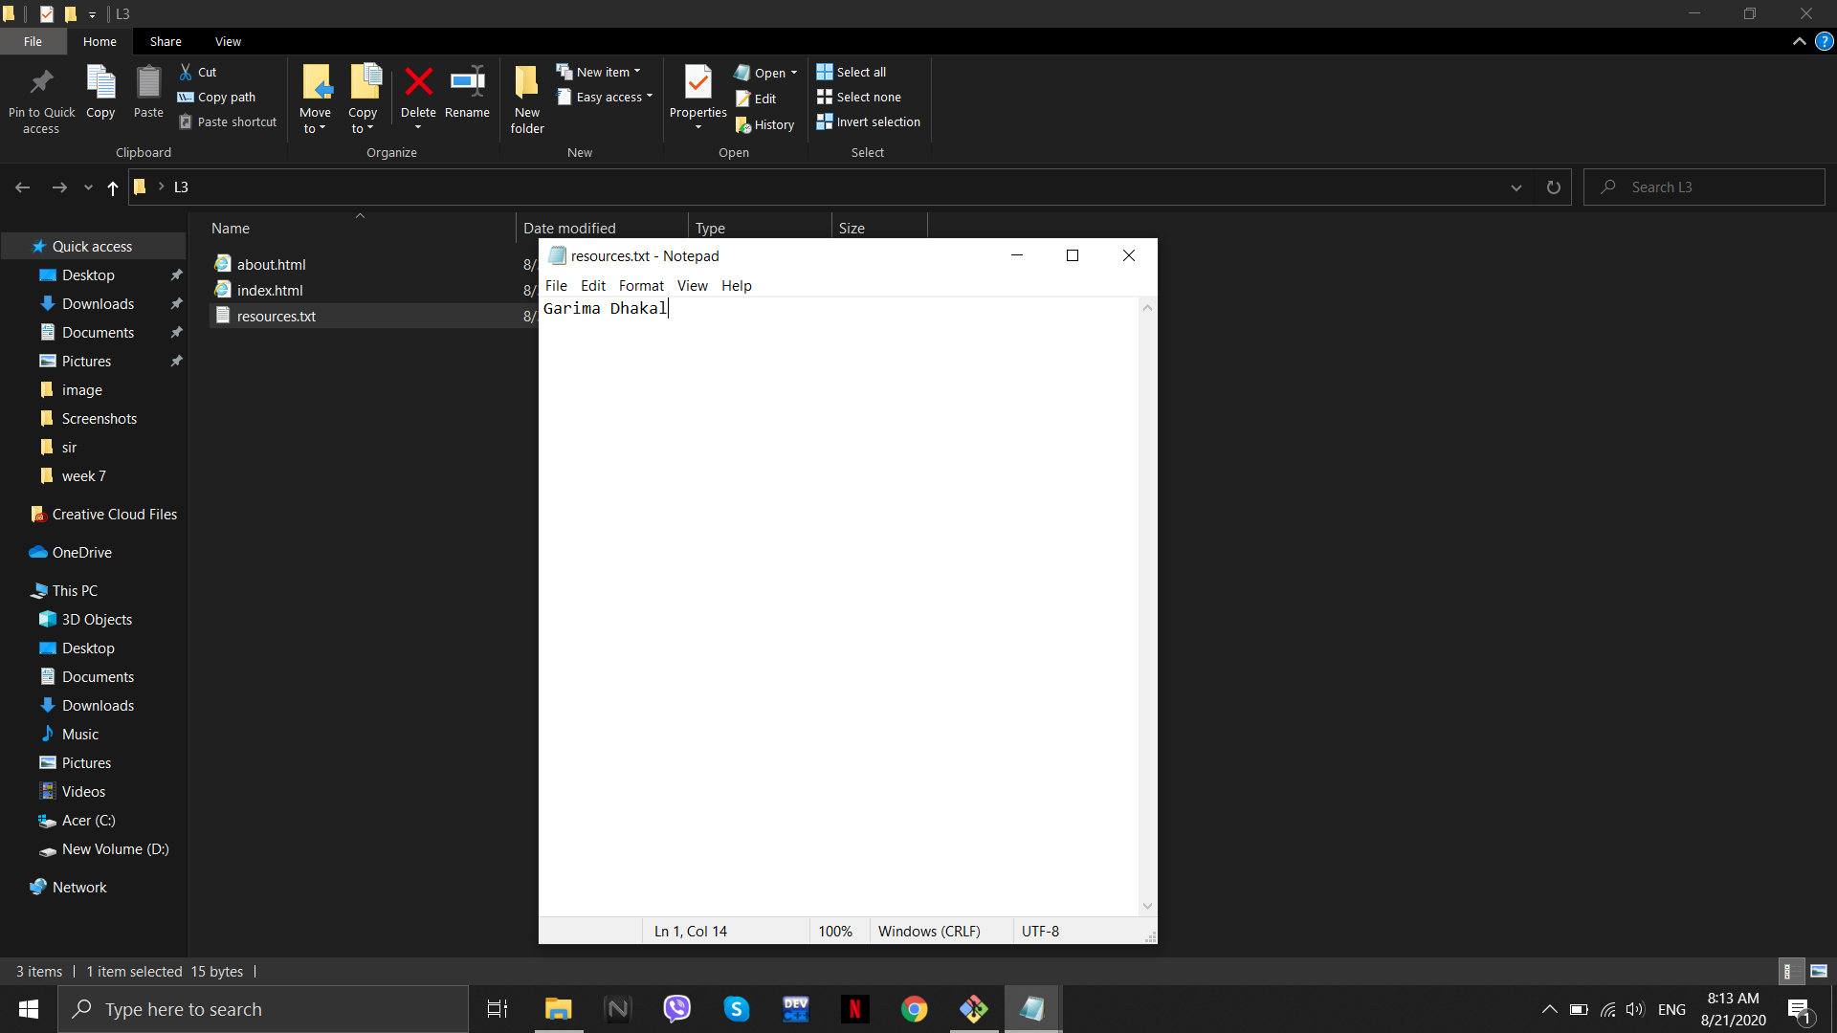

Figure 3: Resources.txt file (name added)

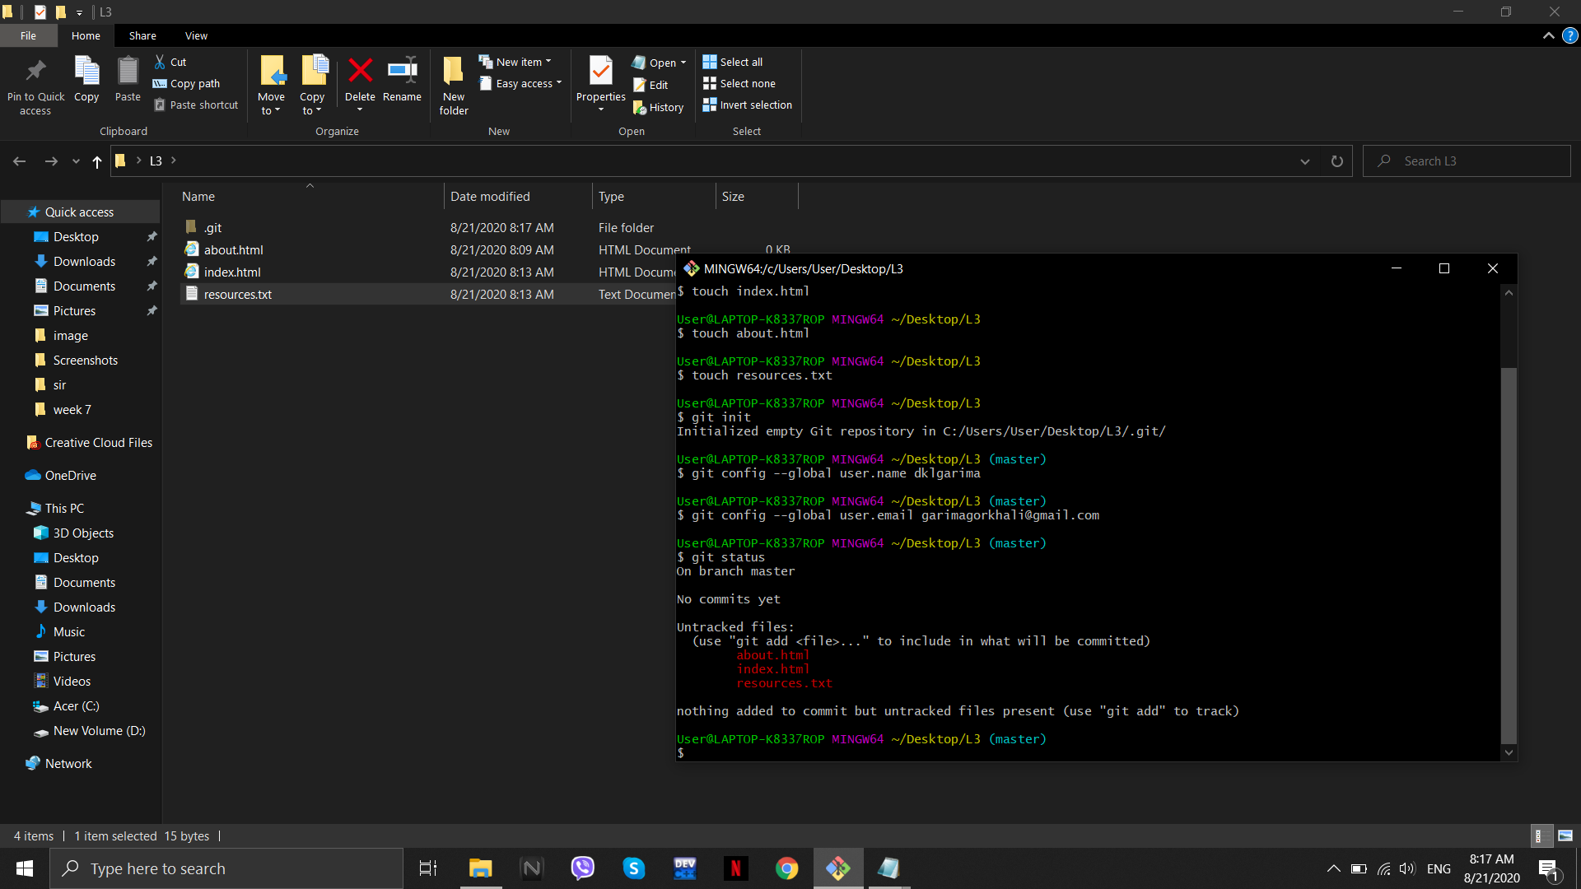

Figure 4: Basic Github code done

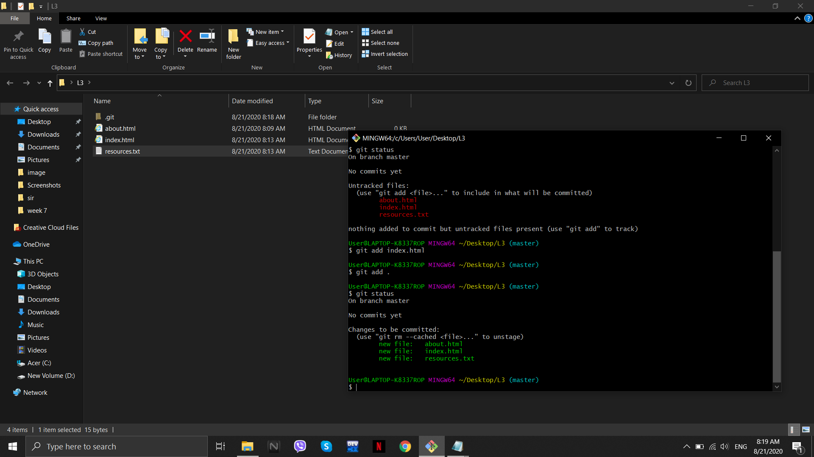

Figure 5: Files added

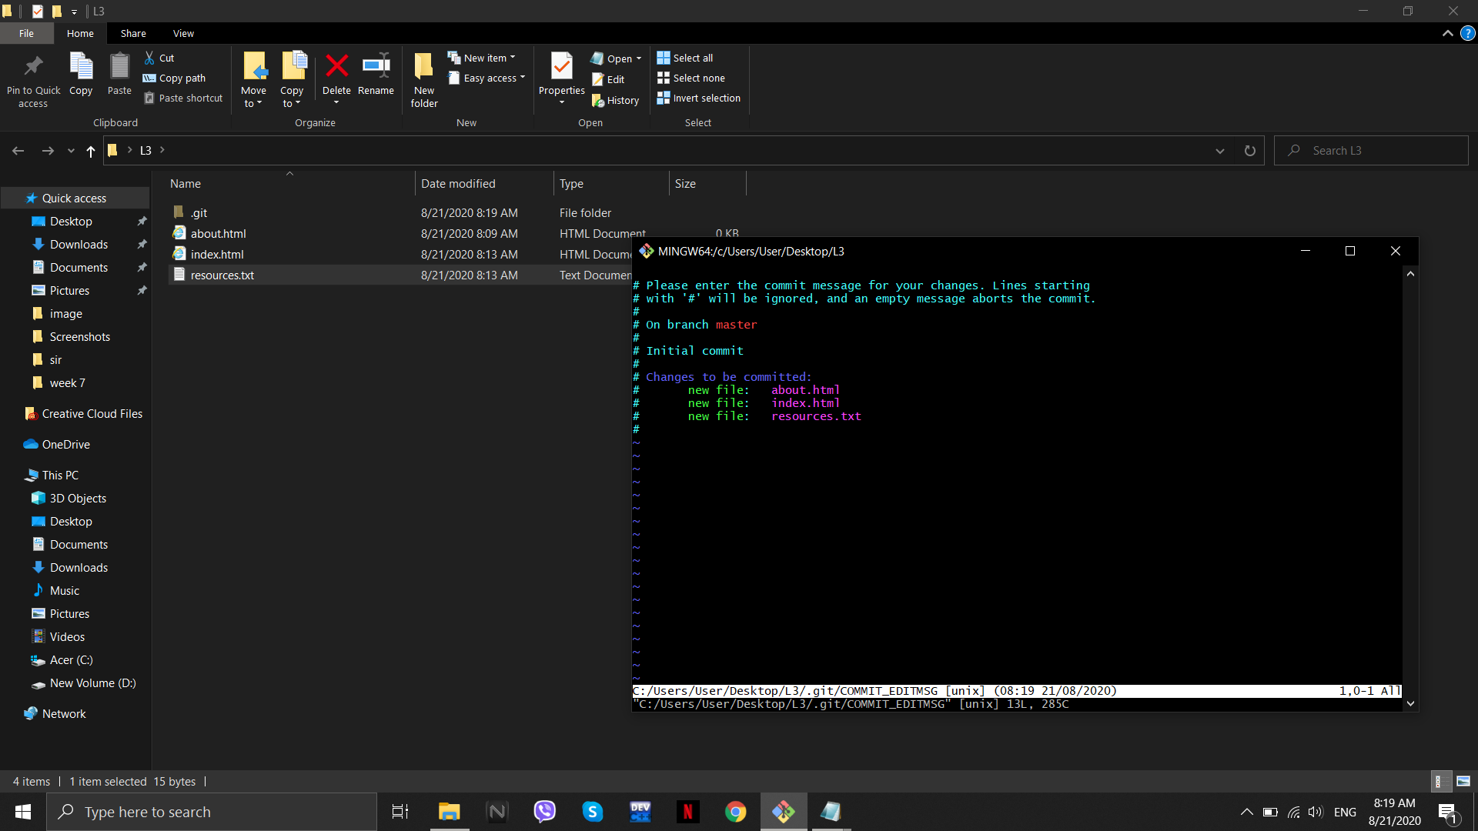

Figure 6: Initial commit

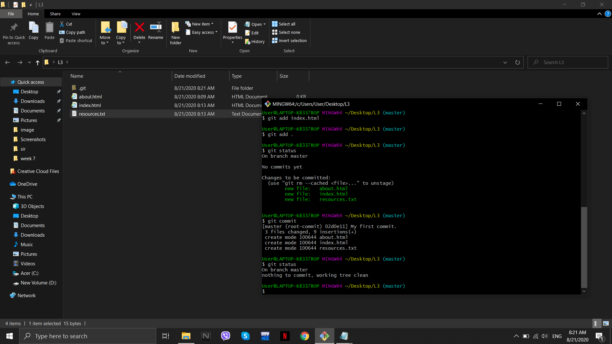

Figure 7: Checking Git status

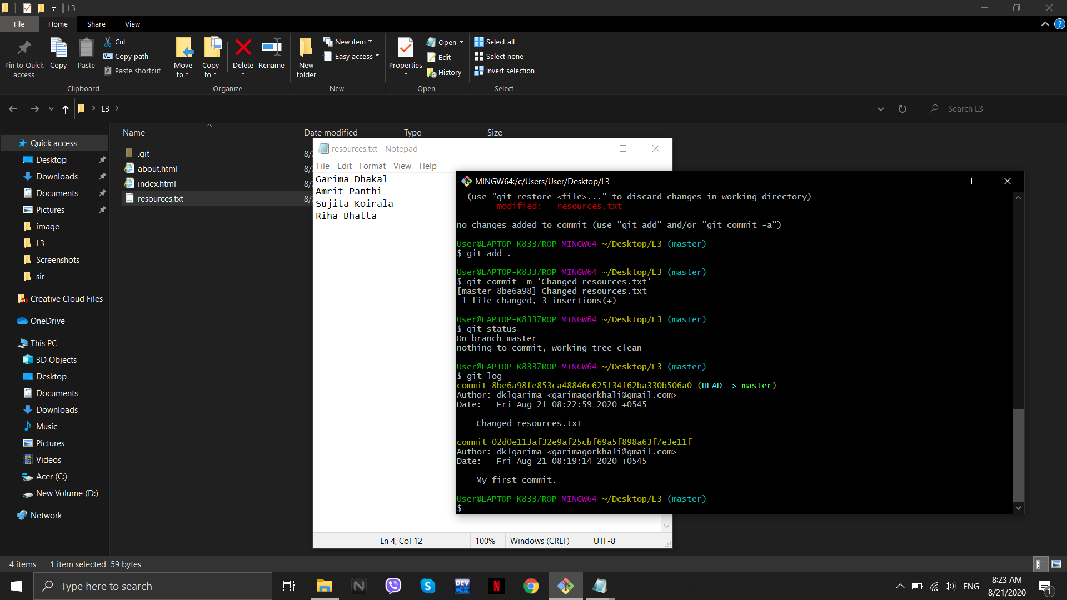

Figure 8: Modified resources.txt file

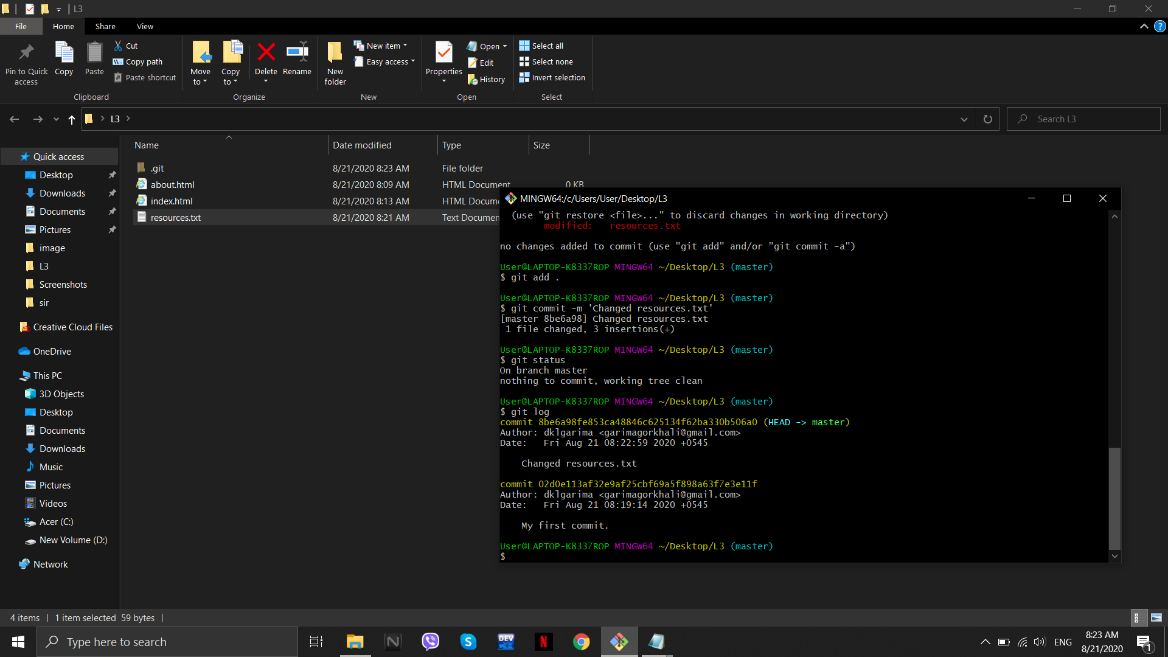

Figure 9: Commit added

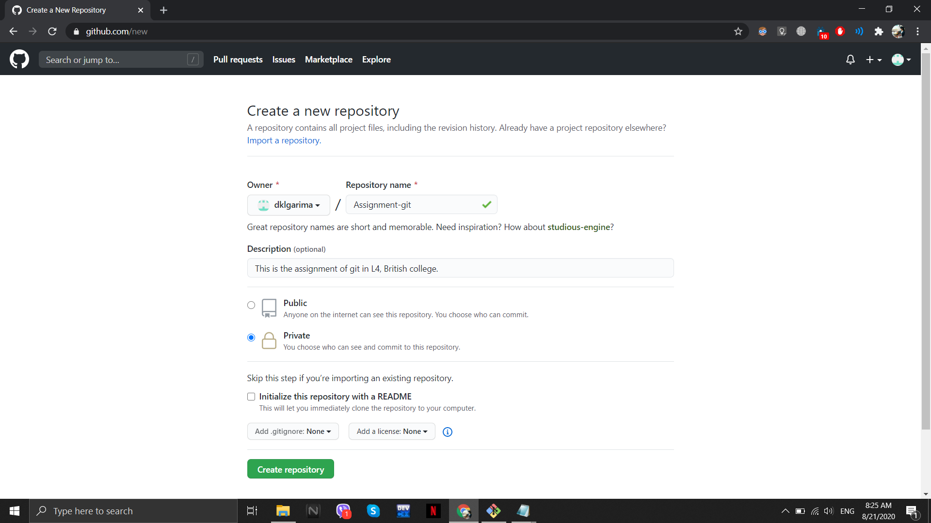

Figure 10: Repository created

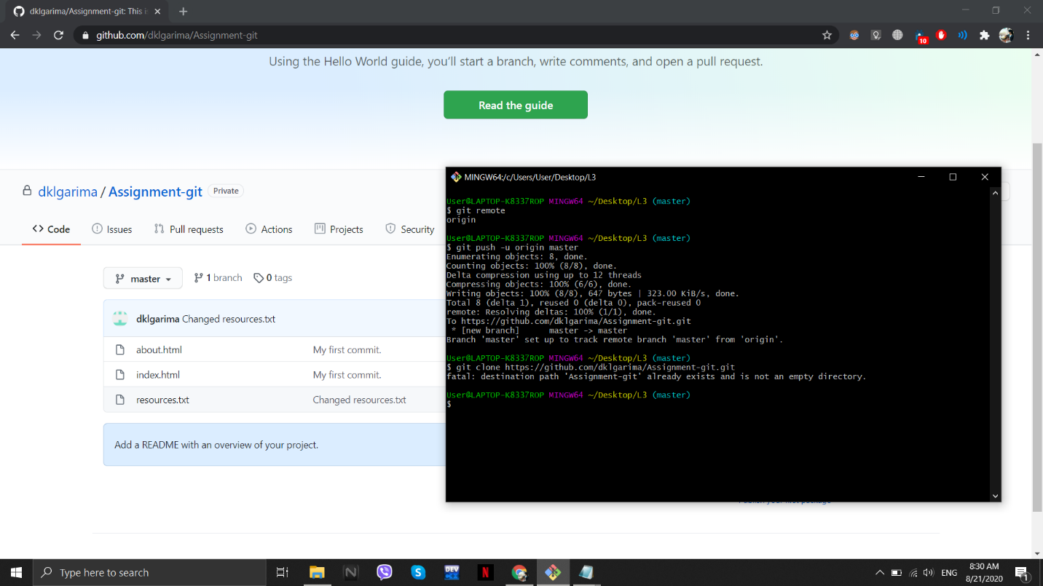

Figure 11: Files added and cloned in repository